Hardware Design:
The hardware design was comprised of 3 main components: The sensor array, the feedback motor control system, and the board itself. Initially, we used a standard protoboard for prototyping. The sensors used were piezoelectric sensors, providing a positive voltage when pressure is applied, and a negative voltage when pressure is released. Something to note; it provides a signal based on the edge, not the peak, of pressure. For example, if we modeled the applied pressure as sign wave, the sensors would provide a positive voltage at a magnitude matching the rate of change, positive or negative, with 0 voltage at the peak and trough of the wave. This is an important limitation we had to keep in mind, but ultimately this type of data is sufficient.

When hooked directly to an oscilloscope, these piezoelectric sensor were capable of producing over 50 volts! What's more, an equally large negative voltage could be induced when the pressure is released. But the pins on the Seeed[sic] board are not configured for this magnitude of voltage, or any negative voltage at all so a system had to be designed to compensate.

The max allowable voltage range that the seeed board could safely take is 0V to 3.3V, though as high as 3.7V could be accepted according to some documentation. First, the sensors positive terminal are feed through a diode, to ensure current could only pass one way. Then, through a 2k Ohm resistor to limit current. Finally, a reverse biased Zener diode with a 3.0V Zener voltage, which then connects to ground. The negative terminal of the sensors also connects to ground here. The seeed board pins were set up to measure the pins between the resistor and the Zener diode, thus ensuring they would only ever measure a maximum voltage of 3.0V, thanks to the Zener diode.

Initially, the haptic feedback motor was supposed to be powered by a pin on the board. However, during initial testing of this idea, the pin providing the voltage was accidentally damaged; the pins were only rated at a fraction of the current the motor needed. So, a NPN transistor was incorporated that used a pin to control it’s gate was substituted. A PNP transistor was tried, and with a minor programming change was able to function, but the NPN transistor was chosen instead, so that any future damage to the control pin would be immediately noticeable, as a high digital voltage must be applied from that pin to prevent the motor from vibrating continuously.

First, the 3.3V pin of the board feeds into a 10 ohm resistor; this is just to prevent any surge current issues. Next, this connects to the positive terminal of the haptic feedback motor. The negative end then connects to the collector of the NPN transistor. The emitter is then connected directly to ground. The gate is controlled by a pin on the seeed board, which passes through a 47k ohm resistor. This number was somewhat arbitrary; It only exists to prevent any accidental overdraw from the more sensitive pins, and a much higher or lower resistor would also be sufficient.

With a maximum listed terminal voltage on the motor being 75 ohms, this circuit, when closed, should draw only 38mA. Even assuming the terminal resistance is a third its rated number, this still keeps the current draw well under 100mA.

Finally, the board. Initially, we used a rigid protoboard for the circuit design, but we sought alternatives almost immediately. It was unnecessarily thick, it had limited space for components, and was too rigid for the application. It needed to be strategically damaged to split some columns to make space. As such, we swapped to a surface mounting optimized flexible protoboard for the second iterations. The surface mounted components were orders of magnitude smaller, and the flex-board did not have connected rows or columns, making it possible for our design to be much more compact.
Hardware Fabrication:
At present, all circuit fabrication is done by hand. Components are soldered together in the order described in the hardware design section.
First, a section of flex board 26 nodes by 19 nodes is cut. Measurement was made by nodes, as the flexible nature of the insole and the board meant that tolerances on size were high, but the need for specific arrangement of components meant that this arrangement of nodes were required.

After the board is cut, a notch is made, cutting an area between nodes 6 and 14, 9 nodes deep. This cutout will house the Xiao Seeed board. The seeed board is hot glued in place, then wires are soldered connecting pins D2 through D5 to the next nearest node on the flex-board. Four wires, one to each pin connecting to one of the four nodes. Each of these nodes then branch in two directions. One goes to the 2k ohm resistor, which in turn will next connect to their diodes, and finally the positive terminal on the piezoelectric sensors. The other branch of each goes to a reverse biased 3.0V Zener diode, which in turn connects to ground and the negative terminal ports for the sensors.

Each of the pairs of ports used to connect to the port use the female pin ports that come standard with most prototyping kits, soldered to a node and hot-glued down to prevent them coming loose. After soldering of components was finished, all components capable of moving at all received a generous dose of hot glue. This includes the seeed board.

Software Design:

The softwre used to interperate the signals from the sensors utilizes an unsigned long stack to log exery timestamp on each of the sensors where pressure is being applied. In a normal step, you would expect pressure to first be applied at the heel first then rock forward, applying preasure to each of the four sensors in turn, sequentially. However, the sensors can be a bit overly sensitive and pick up pressure caused by other movement. As such, when a step is completed, it checks to see if ANY of the logged timestaps on the previous sensor were before the current sensor. If the top of the stack logging this data is not, that data is popped, and checked again untill the stack is empty of good data is found. If good data is found, the score is incremented It then repeats this process with the previous sensor as the current sensor. As long as each sensor was tripped within one second of each other, in the correct sequence, it will log as a good step.

Additionally, to make the system somewhat more robust, a scoring system is implemented; only 3 out of 4 possible “points” from correct sequences are required to log a good step. If the data gives the algorithm some reason to doubt it, either be being higher than it should be, or because it is a zero (likely meaning a problem with the sensor itself), it will substitute the last “good” timestamp. This way, if the data from 3 of the 4 arrays would indicate a good step, it will disregard the 4th.

Testing
Several iterations of testing were performed to verify functionality. One involved leaving the device on for a full 24 hours, to verify the battery capacity was sufficient to meet the 12-hour minimum runtime.
Other testing was performed to verify the signal authenticity of the piezoelectric sensor array. Variable amounts of pressure were applied to each sensor in turn to check that no more than 3 volts were measured at the pins at any time. Additionally, on the initial boards, the sensors were triggered to the greatest magnitude they could be 100 times, to verify that full functionality would remain, and that the circuitry designed to prevent high voltages off the sensors was sufficient. Then, it was tested by putting it in a shoe and walking in it.

We tested the structural integrity of the chip by testing it is real-world use cases; we put it in a shoe, and walked on it.

Finally, testing of the software started by testing the scoring algorithm. We manually fed it data using a 3.0V battery, and verified it scored steps.

Analysis from testing

After 24 hours of continuous runtime, the device was still running. From this, we learned that the battery size was absolutely sufficient.
The scoring algorithm was able to correctly measure steps when manually manipulated, but in the live-trial, we discovered that the nature of the piezoelectric meant they were prone to false-positives as the pressure levels on each sensor changed through a normal step.

The structural integrity of the chip was found to be slightly lacking in the initial version. It used a solid-core wire, which was more rigid, to mount the pins of the chip to the board.

The software worked during carefully set up test conditions, but as discovered during real-world testing, the sensors were prone to false positives. Since the software only recorded the timestamp of the last signal, it would override the old data and look like a bad step, despite all necessary signals for a good step being met.

Iteration from analysis

Since all battery was sufficient for requirement, and still had a charge after double the required run time, it was decided that a smaller battery could, if necessary, be used in subsequent models.

The solid core wires that caused earlier fragility were swapped with a more flexible wire, and the chip was found the hold up much better to stress.

Since the false positives were an inherent part of the way the sensors functioned, a fully software fix was implemented. The scoring algorithm was upgraded to only need a majority of the sensors (3 of 4) to agree a step was good. What's more, to prevent overriding of data that would indicate a good step, the algorithm was changed to incorporate a stack of unsigned long values, representing millisecond timestamps. The stack would be searched for any data that would indicate a good step, giving the algorithm “memory” of the pattern of pressure, improving recognition. After these improvements, we recorded a 75% accuracy rate for step recognition, which can still be improved with further refinement, but is currently sufficient to understand macro-trends in walking patterns.

3D TPU Insole:
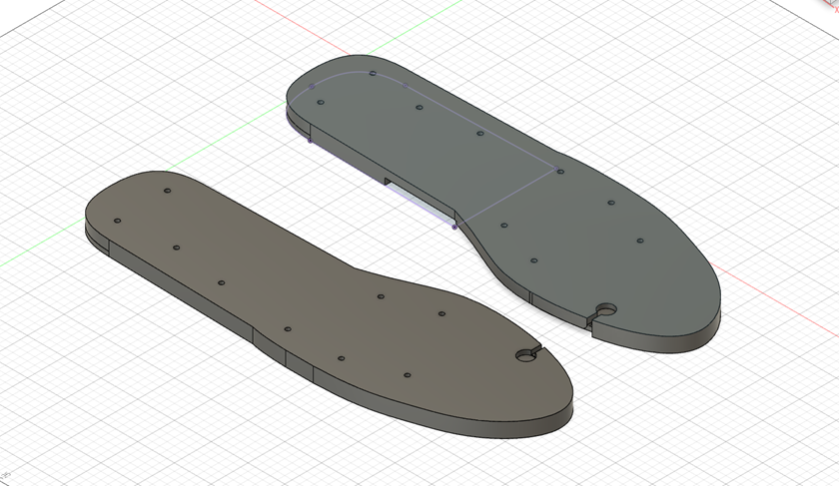
Figure 1
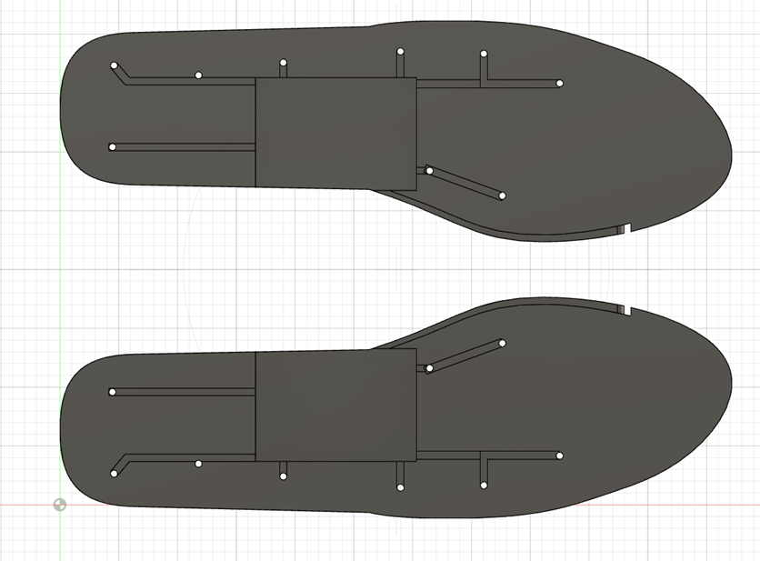
Figure 2

The insole is printed with TPU, and the design is shown by figures 1 and 2. Figure 1 shows the top view of the insoles. Each hole is for the wiring of the piezoelectric sensors so that they can easily be positioned and taped down. At the edge of the big toe there is space for a haptic vibrator that is triggered when Toe walking is detected. The bottom side of the insole also has a channel for the wring of the haptic vibrator. Figure 2 shows the bottom side of the Insole and shows the channel for the vibratos wire connection. It also has channels that start at the board housing that connect to the holes for the piezoelectric sensors wiring.

3D TPU Insole:

The insoles had many improvements while the project progressed. The original model was made for a board not using a flex board but a typical PCB test board. When changed to the flex board the housing for the board was shortened since it reduced the thickness that was needed for it. Many more iterations of the insole were made, all making minor changes as we printed them and decided the aspects that worked and what needed to be changed.
Flexible Lithium Ceramic Batteries (FLCB)
While FLCB’s are still in a research and development state they could become a great innovation for future iterations of SmartStepper. A major issue with the current design is the battery and safety concern it causes. Lithium batteries expand and can get hot plus there’s the added danger of harming the battery. Since these are primarily for kids and will be going in their shoe’s safety is a priority. With these new batteries they can be cut and pierced, and the battery causes no harm and is still functional.
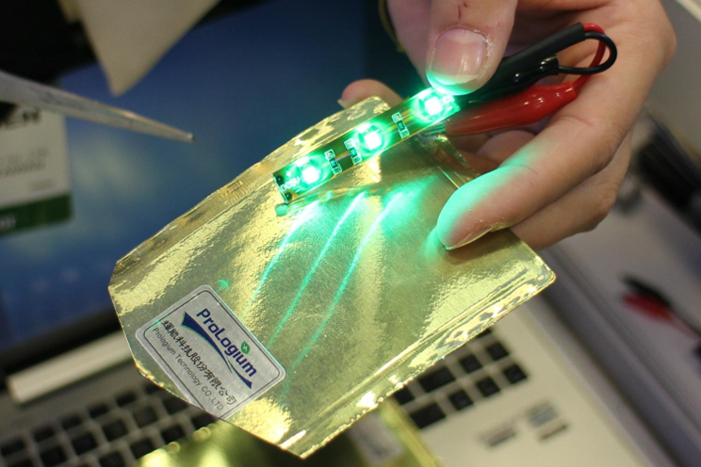
Figure 3(https://www.digitaltrends.com/wearables/prologium-flcb-and-li-metal-battery-news/)

Fusion 360 and Prusa Slicer:
There is 2 programs needed for the development and printing of the 3D insoles. The first is Fusion 360 this was used to design the insole. It is a 3D modeling program that allows design and editing the design as needed and can be used to edit or make a new design for future iterations of the project. The design can then be saved as a .STL file for 3D printing. Prusa Slicer is only used to generate the G-code for the 3D printers. The program is used to have the proper setting which currently is “Generic Flex” material for TPU and a 12% Infill.

Conclusion

The Smart Stepper project is a success. All critical objectives have been met. The device is discrete enough not to be noticeable, due to being entirely internal to the she. It has more than sufficient power for the necessary minimum runtime. It provides real-time feedback from the motor. It provides data collection on the smart watch. It had a positive-feedback system from the game on the watch. It has been designed, refined, and iterated upon multiple times over, and the final product is more than sufficient to call this a success.

